import pandas as pd

ev_data = pd.read_csv('Electric_Vehicle_Population_Data.csv')

print(ev_data.head())

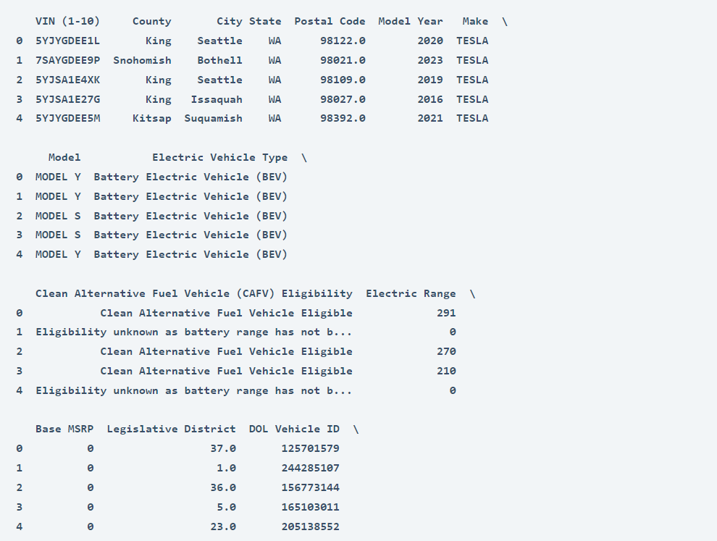

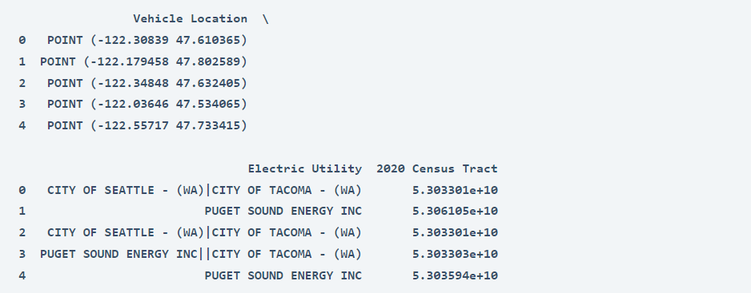

ev_data.info()

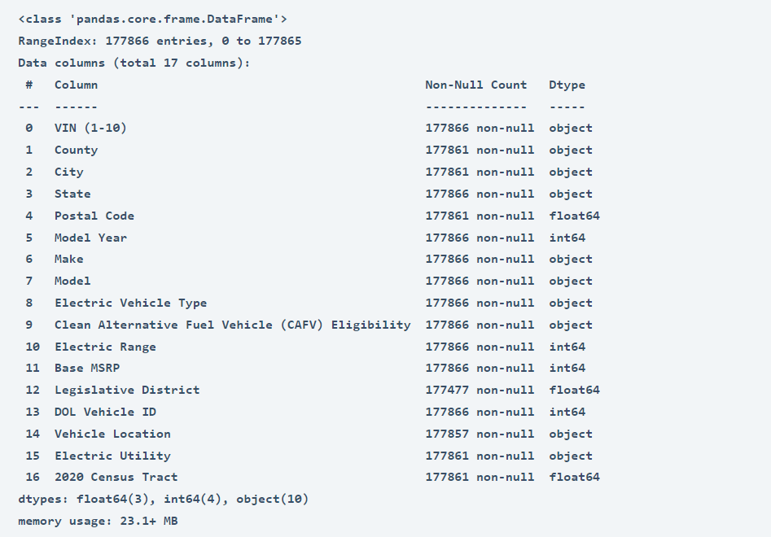

ev_data.isnull().sum()

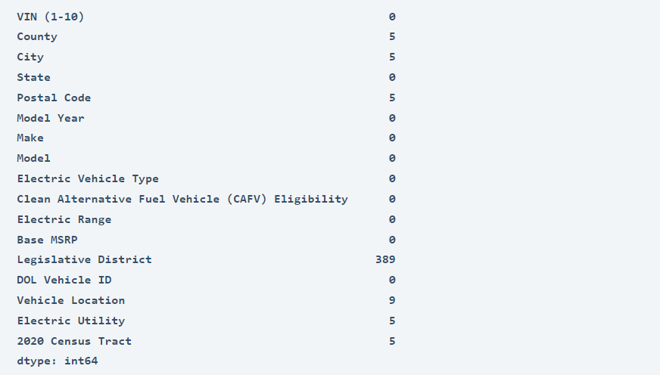

ev_data = ev_data.dropna()

—------------------------------------------------------------------------

EV Adoption Over Time by visualizing the number of EVs registered by model year. It will give us an insight into how the EV population has grown over the years

import matplotlib.pyplot as plt

import seaborn as sns

sns.set_style("whitegrid")

# EV Adoption Over Time

plt.figure(figsize=(12, 6))

ev_adoption_by_year = ev_data['Model Year'].value_counts().sort_index()

sns.barplot(x=ev_adoption_by_year.index, y=ev_adoption_by_year.values, palette="viridis")

plt.title('EV Adoption Over Time')

plt.xlabel('Model Year')

plt.ylabel('Number of Vehicles Registered')

plt.xticks(rotation=45)

plt.tight_layout()

plt.show()

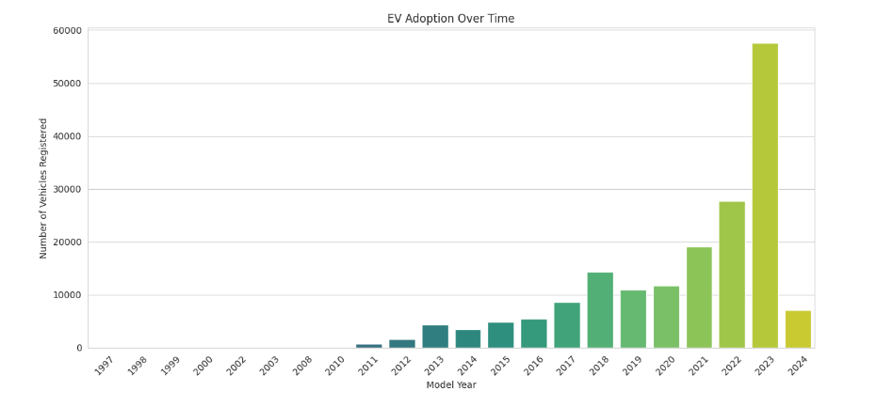

We started by selecting the top 3 counties based on EV registrations and then analyze the distribution of EVs within the cities of those counties:

# geographical distribution at county level

ev_county_distribution = ev_data['County'].value_counts()

top_counties = ev_county_distribution.head(3).index

# filtering the dataset for these top counties

top_counties_data = ev_data[ev_data['County'].isin(top_counties)]

# analyzing the distribution of EVs within the cities of these top counties

ev_city_distribution_top_counties = top_counties_data.groupby(['County', 'City']).size().sort_values(ascending=False).reset_index(name='Number of Vehicles')

# visualize the top 10 cities across these counties

top_cities = ev_city_distribution_top_counties.head(10)

plt.figure(figsize=(12, 8))

sns.barplot(x='Number of Vehicles', y='City', hue='County', data=top_cities, palette="magma")

plt.title('Top Cities in Top Counties by EV Registrations')

plt.xlabel('Number of Vehicles Registered')

plt.ylabel('City')

plt.legend(title='County')

plt.tight_layout()

plt.show()

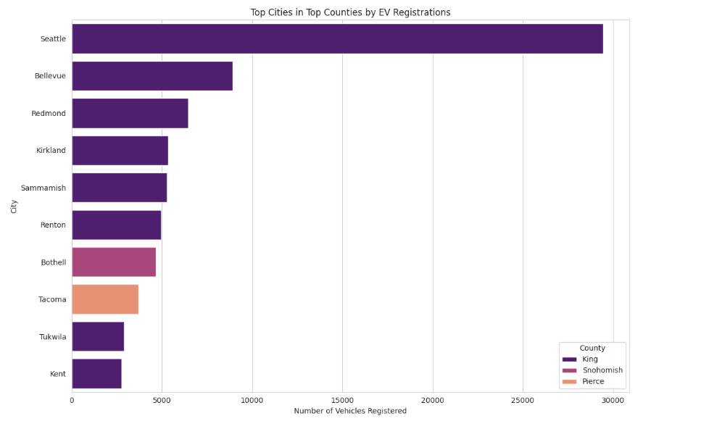

The above graph compares the number of electric vehicles registered in various cities within three counties: King, Snohomish, and Pierce. The horizontal bars represent cities, and their length corresponds to the number of vehicles registered, color-coded by county. Here are the key findings from the above graph:

* Seattle, which is in King County, has the highest number of EV registrations by a significant margin, far outpacing the other cities listed.
* Bellevue and Redmond, also in King County, follow Seattle with the next highest registrations, though these are considerably less than Seattle’s.
* Cities in Snohomish County, such as Kirkland and Sammamish, show moderate EV registrations.
* Tacoma and Tukwila, representing Pierce County, have the fewest EV registrations among the cities listed, with Tacoma slightly ahead of Tukwila.
* The majority of cities shown are from King County, which seems to dominate EV registrations among the three counties.
* Overall, the graph indicates that EV adoption is not uniform across the cities and is more concentrated in certain areas, particularly in King County.

—-----------------------------------------------------------------------------------------------------------------------

Let’s visualize the distribution of electric vehicle types to see which categories are most popular among the registered vehicles:

# analyzing the distribution of electric vehicle Types

ev_type_distribution = ev_data['Electric Vehicle Type'].value_counts()

plt.figure(figsize=(10, 6))

sns.barplot(x=ev_type_distribution.values, y=ev_type_distribution.index, palette="rocket")

plt.title('Distribution of Electric Vehicle Types')

plt.xlabel('Number of Vehicles Registered')

plt.ylabel('Electric Vehicle Type')

plt.tight_layout()

plt.show()

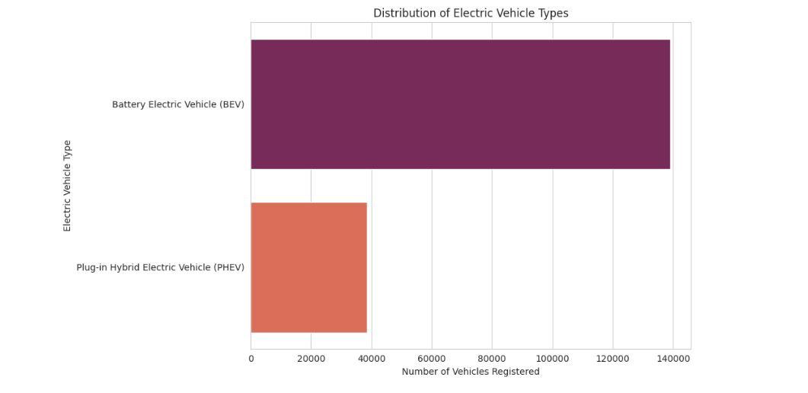

let’s have a look at the most popular manufacturers and then drill down into the most popular models within those manufacturers:

# analyzing the popularity of EV manufacturers

ev_make_distribution = ev_data['Make'].value_counts().head(10) # Limiting to top 10 for clarity

plt.figure(figsize=(12, 6))

sns.barplot(x=ev_make_distribution.values, y=ev_make_distribution.index, palette="cubehelix")

plt.title('Top 10 Popular EV Makes')

plt.xlabel('Number of Vehicles Registered')

plt.ylabel('Make')

plt.tight_layout()

plt.show()

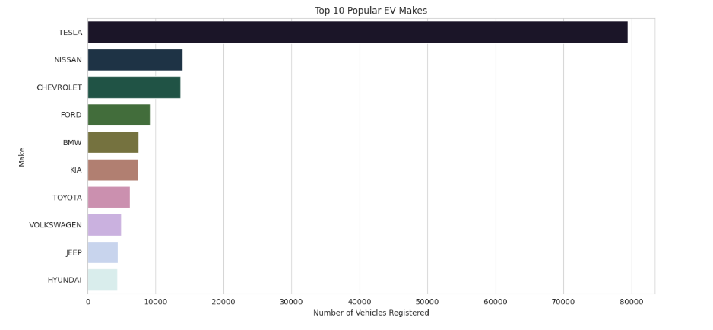

The above chart shows that:

* TESLA leads by a substantial margin with the highest number of vehicles registered.
* NISSAN is the second most popular manufacturer, followed by CHEVROLET, though both have significantly fewer registrations than TESLA.
* FORD, BMW, KIA, TOYOTA, VOLKSWAGEN, JEEP, and HYUNDAI follow in decreasing order of the number of registered vehicles.

—----------------------------------------------------------------------------------------------------------------------------

let’s drill down into the most popular models within these top manufacturers to get a more detailed understanding of consumer preferences at the model level:

# selecting the top 3 manufacturers based on the number of vehicles registered

top_3_makes = ev_make_distribution.head(3).index

# filtering the dataset for these top manufacturers

top_makes_data = ev_data[ev_data['Make'].isin(top_3_makes)]

# analyzing the popularity of EV models within these top manufacturers

ev_model_distribution_top_makes = top_makes_data.groupby(['Make', 'Model']).size().sort_values(ascending=False).reset_index(name='Number of Vehicles')

# visualizing the top 10 models across these manufacturers for clarity

top_models = ev_model_distribution_top_makes.head(10)

plt.figure(figsize=(12, 8))

sns.barplot(x='Number of Vehicles', y='Model', hue='Make', data=top_models, palette="viridis")

plt.title('Top Models in Top 3 Makes by EV Registrations')

plt.xlabel('Number of Vehicles Registered')

plt.ylabel('Model')

plt.legend(title='Make', loc='center right')

plt.tight_layout()

plt.show()

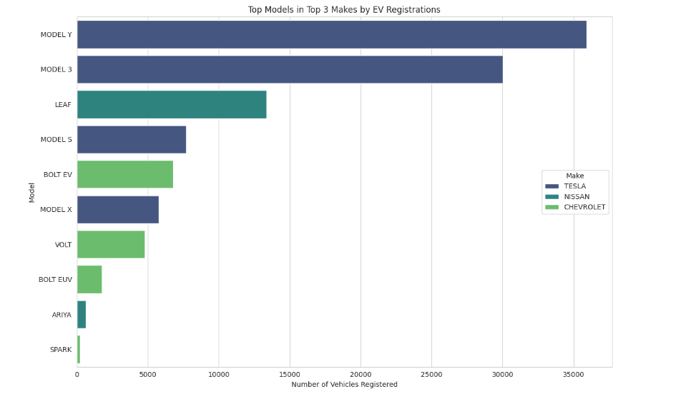

The above graph shows the distribution of electric vehicle registrations among different models from the top three manufacturers: TESLA, NISSAN, and CHEVROLET. Here are the findings:

* TESLA’s MODEL Y and MODEL 3 are the most registered vehicles, with MODEL Y having the highest number of registrations.
* NISSAN’s LEAF is the third most registered model and the most registered non-TESLA vehicle.
* TESLA’s MODEL S and MODEL X also have a significant number of registrations.
* CHEVROLET’s BOLT EV and VOLT are the next in the ranking with considerable registrations, followed by BOLT EUV.
* NISSAN’s ARIYA and CHEVROLET’s SPARK have the least number of registrations among the models shown.

—-------------------------------------------------------------------------------------------------------------------------

Let’s look at the distribution of electric ranges in the dataset and identify any notable trends, such as improvements over time or variations between different vehicle types or manufacturers:

# analyzing the distribution of electric range

plt.figure(figsize=(12, 6))

sns.histplot(ev_data['Electric Range'], bins=30, kde=True, color='royalblue')

plt.title('Distribution of Electric Vehicle Ranges')

plt.xlabel('Electric Range (miles)')

plt.ylabel('Number of Vehicles')

plt.axvline(ev_data['Electric Range'].mean(), color='red', linestyle='--', label=f'Mean Range: {ev_data["Electric Range"].mean():.2f} miles')

plt.legend()

plt.show()

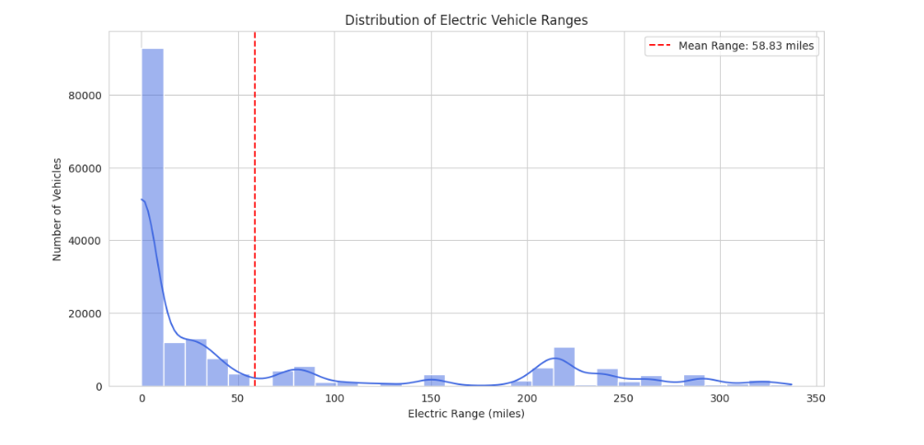

The above graph shows the mean electric range. Key observations from the graph include:

* There is a high frequency of vehicles with a low electric range, with a significant peak occurring just before 50 miles.
* The distribution is skewed to the right, with a long tail extending towards higher ranges, although the number of vehicles with higher ranges is much less frequent.
* The mean electric range for this set of vehicles is marked at approximately 58.84 miles, which is relatively low compared to the highest ranges shown in the graph.
* Despite the presence of electric vehicles with ranges that extend up to around 350 miles, the majority of the vehicles have a range below the mean.

—--------------------------------------------------------------------------------------------------------------------------

let’s delve into the trend of electric ranges over model years, which can provide insights into how advancements in battery technology and vehicle design have influenced the electric range capabilities of electric vehicles over time.

# calculating the average electric range by model year

average_range_by_year = ev_data.groupby('Model Year')['Electric Range'].mean().reset_index()

plt.figure(figsize=(12, 6))

sns.lineplot(x='Model Year', y='Electric Range', data=average_range_by_year, marker='o', color='green')

plt.title('Average Electric Range by Model Year')

plt.xlabel('Model Year')

plt.ylabel('Average Electric Range (miles)')

plt.grid(True)

plt.show()

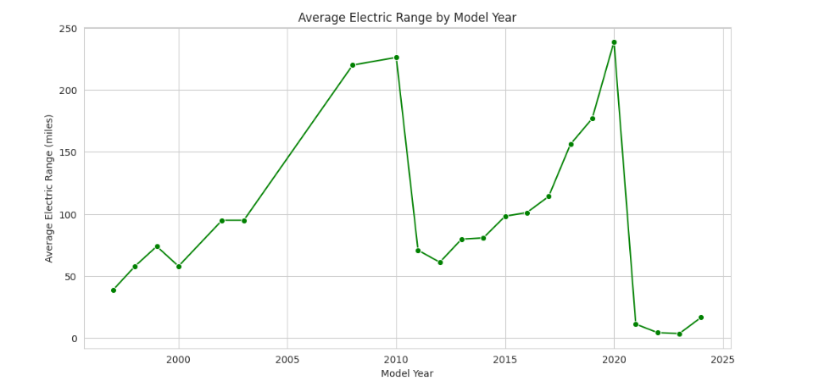

The above graph shows the progression of the average electric range of vehicles from around the year 2000 to 2024. Key findings from the graph:

* There is a general upward trend in the average electric range of EVs over the years, indicating improvements in technology and battery efficiency.
* There is a noticeable peak around the year 2020 when the average range reaches its highest point.
* Following 2020, there’s a significant drop in the average range, which could indicate that data for the following years might be incomplete or reflect the introduction of several lower-range models.
* After the sharp decline, there is a slight recovery in the average range in the most recent year shown on the graph.

—-------------------------------------------------------------------------------------------------------------------------

How electric ranges vary among the top manufacturers and models

average_range_by_model = top_makes_data.groupby(['Make', 'Model'])['Electric Range'].mean().sort_values(ascending=False).reset_index()

# the top 10 models with the highest average electric range

top_range_models = average_range_by_model.head(10)

plt.figure(figsize=(12, 8))

barplot = sns.barplot(x='Electric Range', y='Model', hue='Make', data=top_range_models, palette="cool")

plt.title('Top 10 Models by Average Electric Range in Top Makes')

plt.xlabel('Average Electric Range (miles)')

plt.ylabel('Model')

plt.legend(title='Make', loc='center right')

plt.show()

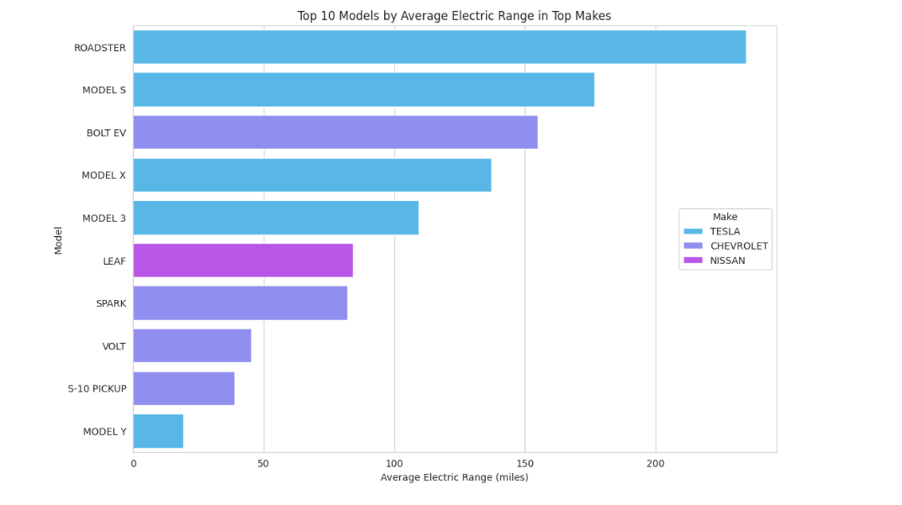

Conclusion

* The TESLA ROADSTER has the highest average electric range among the models listed. TESLA’s models (ROADSTER, MODEL S, MODEL X, and MODEL 3) occupy the majority of the top positions, indicating that on average, TESLA’s vehicles have higher electric ranges.
* The CHEVROLET BOLT EV is an outlier among the CHEVROLET models, having a substantially higher range than the VOLT and S-10 PICKUP from the same maker.
* NISSAN’s LEAF and CHEVROLET’s SPARK are in the lower half of the chart, suggesting more modest average ranges.

—------------------------------------------------------------------------------------------------------------

## **Estimated Market Size Analysis of Electric Vehicles in the United States**

# calculate the number of EVs registered each year

ev_registration_counts = ev_data['Model Year'].value_counts().sort_index()

ev_registration_counts

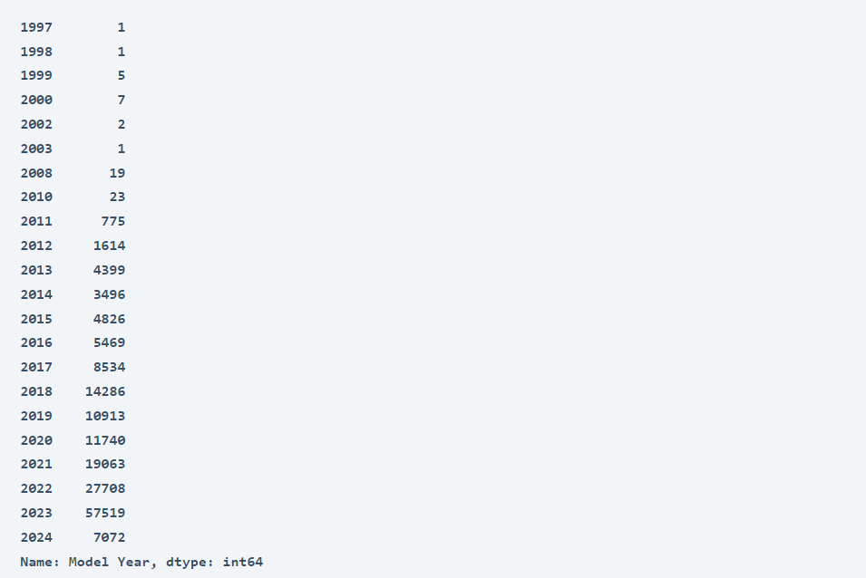

The dataset provides the number of electric vehicles registered each year from 1997 through 2024. However, the data for 2024 is incomplete as it only contains the data till March. Here’s a summary of EV registrations for recent years:

* In 2021, there were 19,063 EVs registered.
* In 2022, the number increased to 27708 EVs.
* In 2023, a significant jump to 57,519 EVs was observed.
* For 2024, currently, 7,072 EVs are registered, which suggests partial data.

Calculating the Compound Annual Growth Rate (CAGR) between a recent year with complete data (2023) and an earlier year to project the 2024 figures. Additionally, using this growth rate, we can estimate the market size for the next five years.

from scipy.optimize import curve_fit

import numpy as np

# filter the dataset to include years with complete data, assuming 2023 is the last complete year

filtered_years = ev_registration_counts[ev_registration_counts.index <= 2023]

# define a function for exponential growth to fit the data

def exp_growth(x, a, b):

return a * np.exp(b * x)

# prepare the data for curve fitting

x_data = filtered_years.index - filtered_years.index.min()

y_data = filtered_years.values

# fit the data to the exponential growth function

params, covariance = curve_fit(exp_growth, x_data, y_data)

# use the fitted function to forecast the number of EVs for 2024 and the next five years

forecast_years = np.arange(2024, 2024 + 6) - filtered_years.index.min()

forecasted_values = exp_growth(forecast_years, *params)

# create a dictionary to display the forecasted values for easier interpretation

forecasted_evs = dict(zip(forecast_years + filtered_years.index.min(), forecasted_values))

print(forecasted_evs)

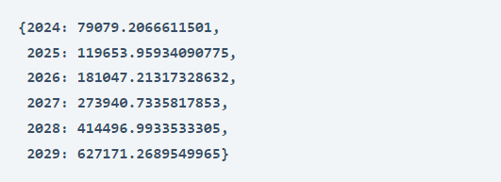

Plotting the estimated market size data:

# prepare data for plotting

years = np.arange(filtered_years.index.min(), 2029 + 1)

actual_years = filtered_years.index

forecast_years_full = np.arange(2024, 2029 + 1)

# actual and forecasted values

actual_values = filtered_years.values

forecasted_values_full = [forecasted_evs[year] for year in forecast_years_full]

plt.figure(figsize=(12, 8))

plt.plot(actual_years, actual_values, 'bo-', label='Actual Registrations')

plt.plot(forecast_years_full, forecasted_values_full, 'ro--', label='Forecasted Registrations')

plt.title('Current & Estimated EV Market')

plt.xlabel('Year')

plt.ylabel('Number of EV Registrations')

plt.legend()

plt.grid(True)

plt.show()

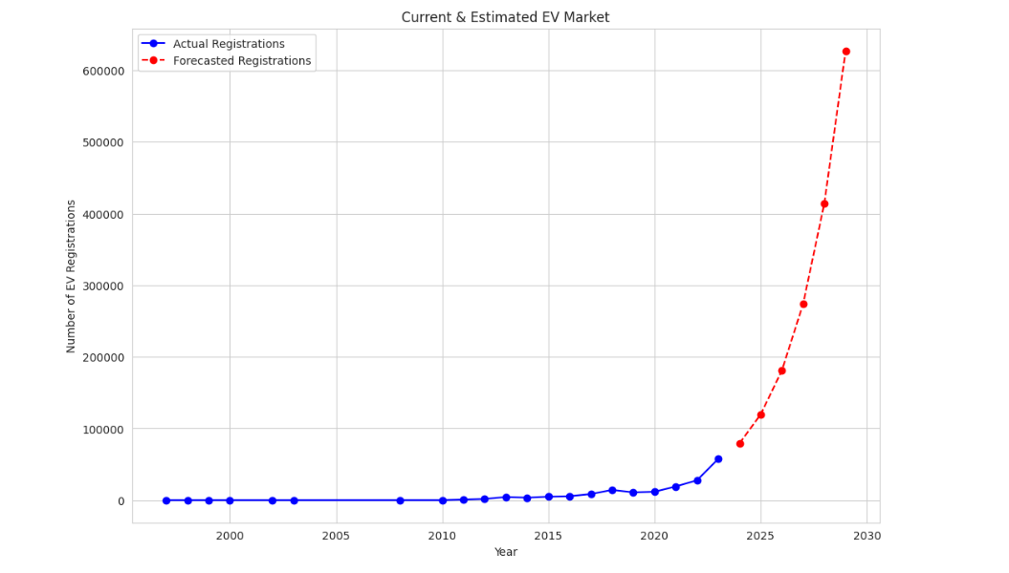

From the above graph, we can see:

* The number of actual EV registrations remained relatively low and stable until around 2010, after which there was a consistent and steep upward trend, suggesting a significant increase in EV adoption.
* The forecasted EV registrations predict an even more dramatic increase in the near future, with the number of registrations expected to rise sharply in the coming years.